Determining the Heat of Reaction in Aqueous Solution
Name
Institution of Affiliation
Determining the Heat of Reaction in Aqueous Solution
Question
Can you determine the heat of reaction in aqueous solution?
Hypothesis
One can measure the heat reaction of an aqueous solution when the volume, molarity and initial temperature of the solutions is known.
Procedure
The experiment was done in two parts. In the first part, 1M solution of A and 1M solution of B in prepared flask that contained 100 mL of solution were taken from the stock room and their temperature noted and recorded. Both solutions A and B were poured in an empty Erlenmeyer flask. The final temperature of the mixed solutions was determined and recorded. The data was then used to calculate the heat of reaction of the two solutions.
In the second part, two solutions were created using water and the reagent provided such that when the two solutions were poured in one flask, the resulting solution would have an initial temperature of 50 ⁰C. This was done in the following way: 51.67 mL of distilled water was put in 250 mL Erlenmeyer flask and this was repeated for another 250 mL Erlenmeyer flask. 50 mL of 3M solution A was added to one of the flask containing 51.67 mL distilled and 50 mL of 3M solution B was put on the other flask containing 51.67 mL distilled water. The resulting solutions were then poured into a 500 mL Erlenmeyer flask that had been insulated at 25 ⁰C. The resulting temperature of the mixed solutions was then recorded.
Results
Table 1: Results of part 1
Solution | Volume | Molarity | Initial temperature
Solution A | 100 mL | 1 M | 25 ⁰C
Solution B | 100 mL | 1 M | 25 ⁰C
Mixed solution | 200 mL | 1M | 41.9 ⁰C

Quantity of heat = mass x ∆T x c
Taking the density of the two solutions to be 1 g/mL
Mass of solution A = 100 mL x 1 g/ml = 100 g
Mass of solution B = 100 mL x 1 g/ml = 100 g
Total mass of solution A and B = 200 g
∆T = final temperature – initial temperature
= 41.9 – 25 = 16.9 ⁰C
C is heat capacity of water 4.18 J/g Kº
Q = 200 x 16.9 x 4.18 = 14128.4 J
Heat of reaction is gotten in kJ per mole
Converting joules to kilojoules, 14128.4/1000
= 14.1284 kJ
There was one mole of each solution and this does not change in the mixed solutions.
Therefore, the heat of reaction is 14.1284 kJ mol⁻¹
Table 2: Part 2 of the Experiment to prepare a mixture of solutions A and B with final temperature of 50 ⁰C
Solution | Volume | Molarity | Initial Temperature
Solution A  Distilled water | 50 mL  51.67 mL | 3M | 25 ⁰C
Solution B  Distilled water | 50 mL  51.67 mL | 3M | 25 ⁰C
Mixed Solution | 203.34 mL |  | 50 ⁰C

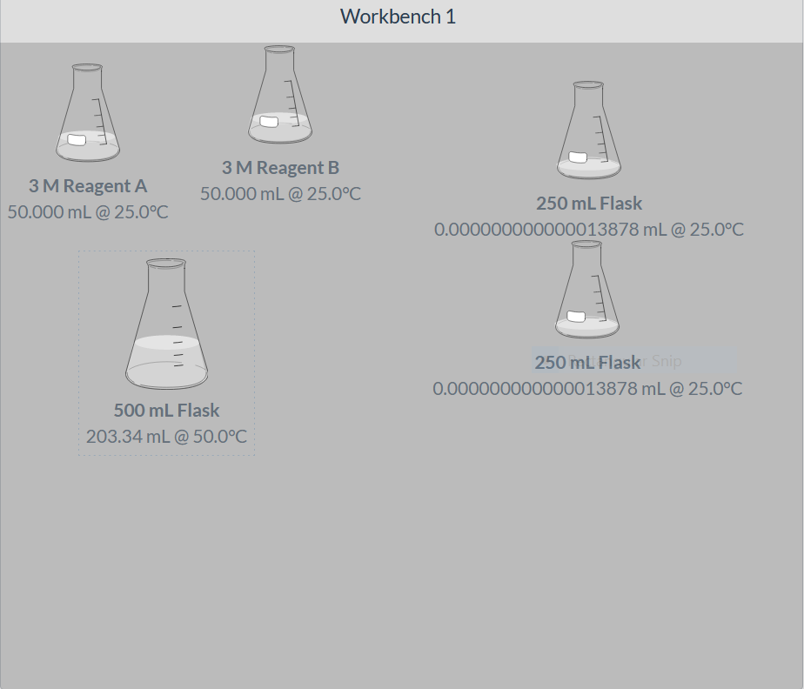
Figure 1: Illustration of part 2 of the experiment.
Analysis/ Conclusion
Results of the experiment showed that the heat of reaction could be determined by combining two reactants as long as their molarity, volume, and initial temperature is known. The change in temperature and taking the specific heat capacity of the solutions to be that of water, the quantity of heat and the subsequent calculation of heat of reaction could be done. The results supported the hypothesis that the heat of reaction can be determined by combining two aqueous solutions. Possible discrepancies could emerge from misreading the data or recording the wrong data otherwise the virtual lab reduces the possibility of errors. Improvements that could be made to yield better results include making the lab more interactive by being able to measure the reagents rather than getting those that had already been measured.

